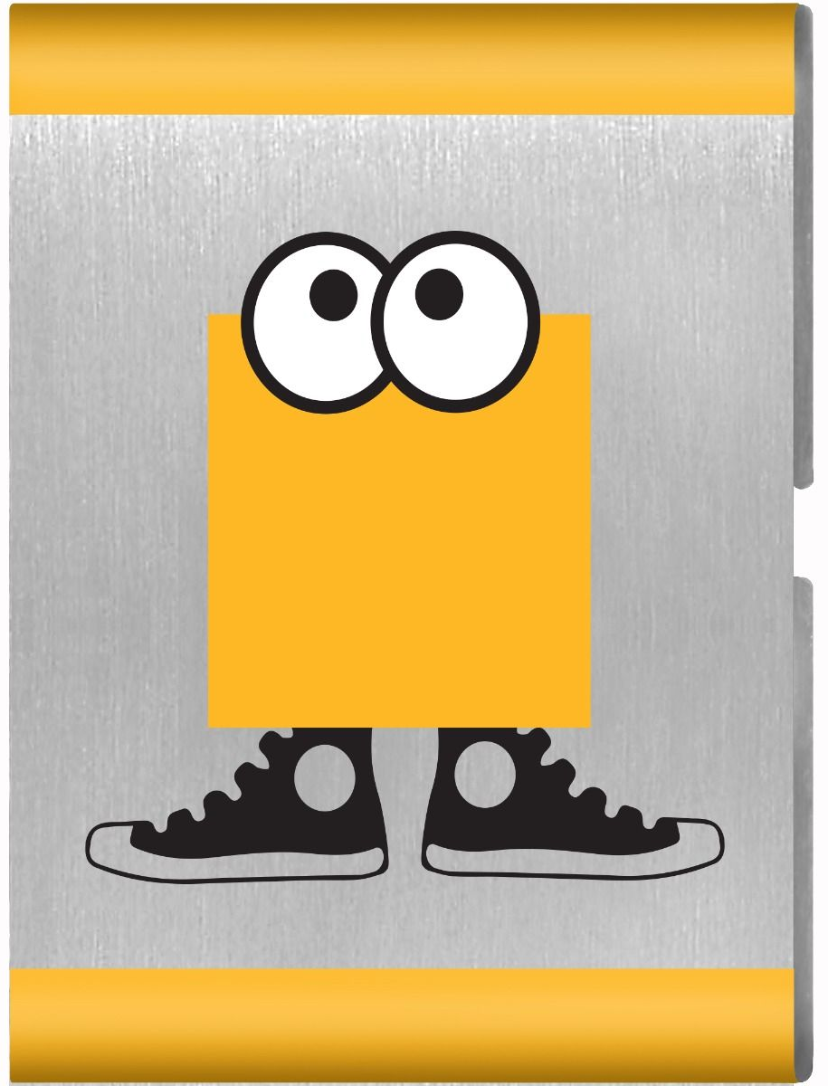
Gizmos and Gadgets

Parent and Leader Guidebook: page 60-62
Lion Adventure Book: page 12

- Explore properties of motion.
- Explore properties of force.
- Use household materials to create a useful object.

Materials
- Copies of King of the Jungle handout, one per adult
- Copy of Den Meeting Plan, one for leader(s)
- Name tags and Sharpie
- Cub Scouts Poster Set with Scout Law, Scout Oath and Den Code of Conduct
(#621086 from Scout Shop)
- Blue tape or something to hang posters on wall

Optional
- Snack and water
- Activities for siblings (e.g., coloring books)

Gathering: Mild Jug Toss
- One-gallon milk jug with bottom cut out for each Lion
- Various items to catch (e.g., bean bags, ping-pong balls, tennis balls)

Activity 1: Rolling Investigation
- Different-sized balls, cylinders, pipes (solid/hollow, cylinders/spheres, large/small) to roll down an incline

Activity 2: Ping Pong Ball Races
- Straws, one per Lion
- Ping-pong balls
- Dominos

Activity 3: Neckerchief Slide
- PVC
- Computer parts, washers, bolts and screws
- Glue (or hot glue gun)

Activity 4: Genius Kits
- Genius Kits, one per Lion (bag with 6-8 identical items: loose gears, twine, nuts and bolts, washers, marbles)

Activity 5: Gadget Collage
- Magazines
- Scissors
- Poster board

Activity Wrap Up
- Colored pencils, crayons or markers
- Few extra copies of Lion Adventure Book page 12 (for those who forget book).
Den Meeting Plan
Gizmos and Gadgets

Gathering
- Milk Jug Toss

Opening
- Good conduct candle
- Pledge, Scout Oath, Scout Law

Talk Time
- Den business
- Sharing time

Activities
- Activity 1: Rolling Investigation (roll items down incline)
  - Which one rolls farthest down incline?
  - When pushed across floor, do they roll at same rate?
- Activity 2: Ping-Pong Ball Races
- Activity 3: Neckerchief Slide
- Activity 4: Genius Kits
- Activity 5: Gadget Collage
- Activity Wrap-up: Lion Adventure Book, page 12

Closing
- Scout Law

Gizmos and Gadgets Adventure

Scout Law
A Scout is trustworthy, loyal, helpful, friendly, courteous, kind, obedient, cheerful, thrifty, brave, clean, reverent.
Scout Oath
On my honor, I will do my best to do my duty to God and my country and to obey the Scout Law; to help other people at all times; to keep myself physically strong, mentally awake, and morally straight.
Upcoming Events

Dec 16 Wreaths Across America, optional
10:00 am at Houston Cemetery

Dec 20 Pack Meeting
(bring donation of first aid supplies)

Jan 10 Den Meeting
TBD Outing

Feb 7 Den Meeting
Feb 24 Pinewood Derby
Feb 28 Pack Meeting
Mar 7 Den Meeting

Pack 72
facebook.com/pack72tomball
pack72tomball.scoutlander.com
Orion District
www.orion.shac.org
facebook.com/orionbsa
Sam Houston Area Council
www.shac.org
facebook.com/shac.bsa

